**Splunk Lab**

* **Intro to Splunk**

* **Using Fields**

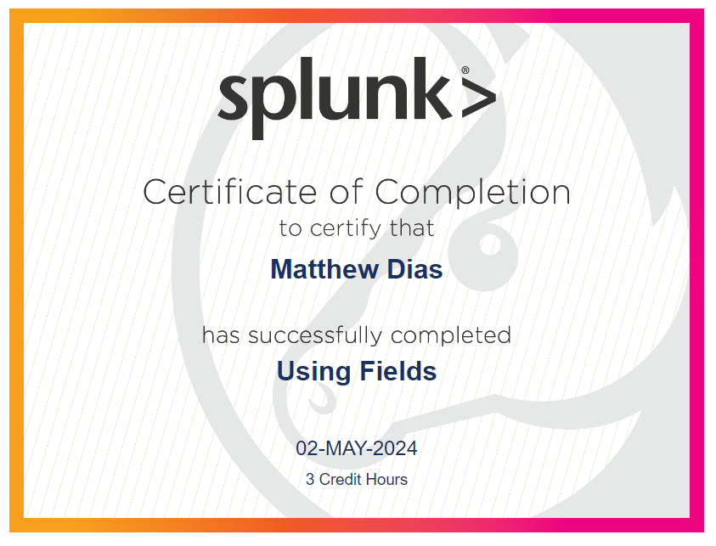

* **Scheduling Reports & Alerts**

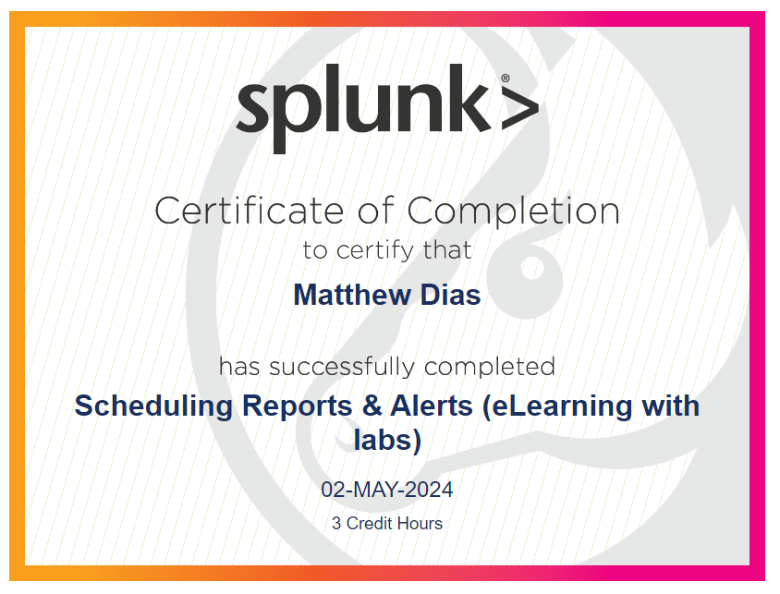

* **Visualization**

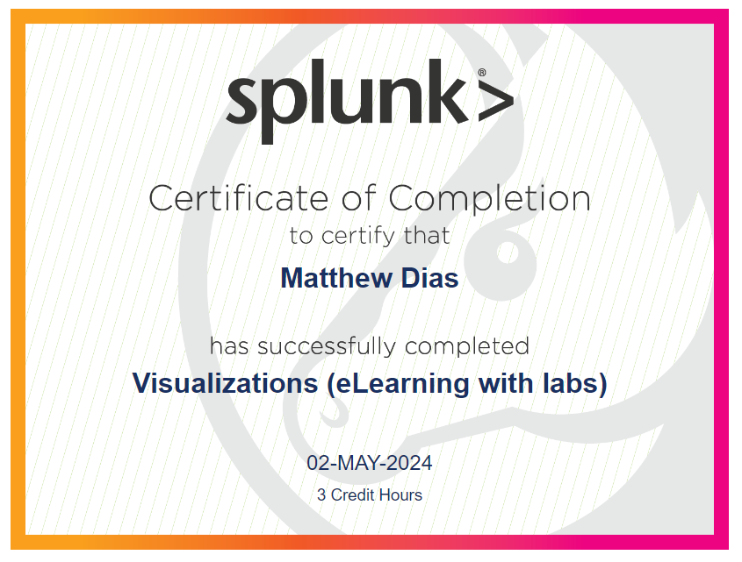

* **Working with Time**

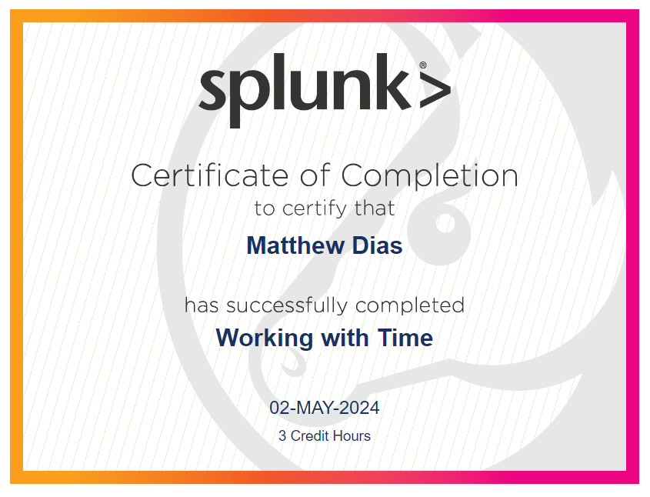

* **Statistical Processing**

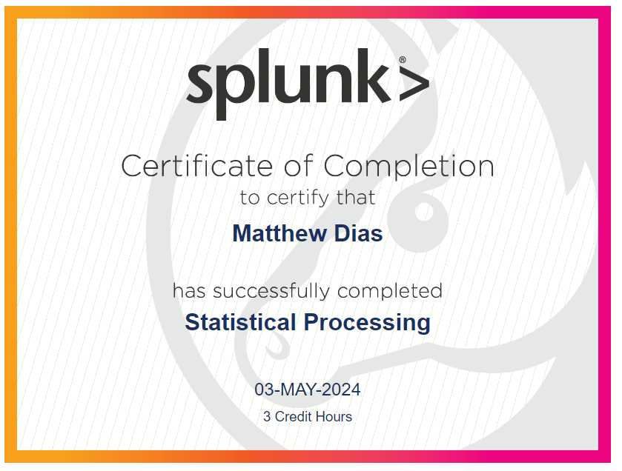

* **Comparing Values**

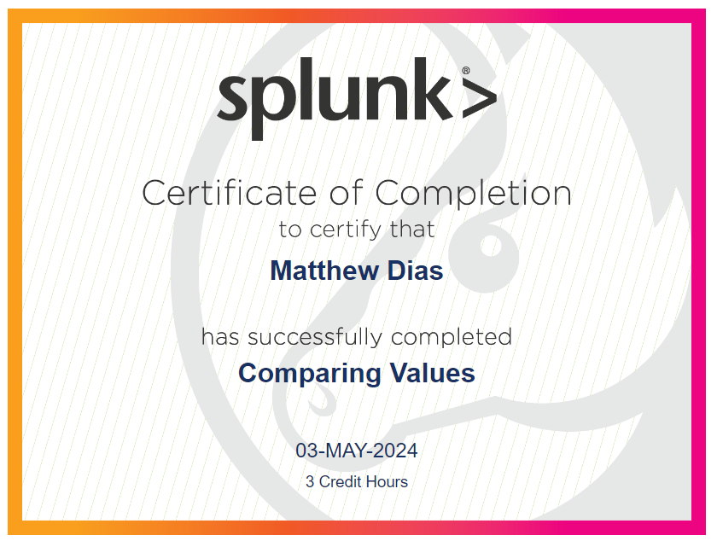

* **Result Modification**

